A.Taiga User Registration/Login Graph.
The control flow graph represents the Taiga user authentication workflow by showing the sequence of registration and login actions, decision points, and possible success or failure outcomes using numbered nodes and directed edges.
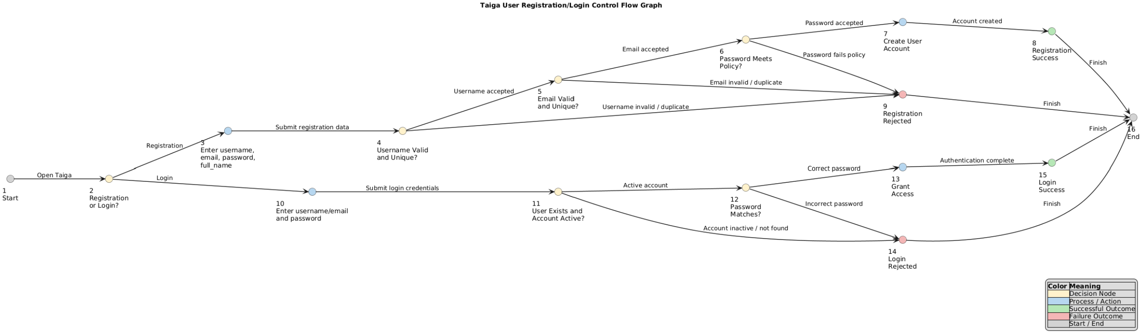

Table A.1: Node Description:
The node description table explains the purpose of each numbered node in the graph and identifies the specific action, validation step, or system state represented by each node.
Node | Description
1 | Start Taiga authentication
2 | User selects Registration or Login
3 | Enter username, email, password, full name
4 | Validate username format and uniqueness
5 | Validate email format and uniqueness
6 | Validate password policy requirements
7 | Create Taiga user account
8 | Registration successful
9 | Registration rejected
10 | Enter username/email and password
11 | Verify user exists and account is active
12 | Verify password correctness
13 | Grant access to Taiga
14 | Login rejected
15 | Login successful
16 | End authentication process

Table A.2: Edge Descriptions:
The edge description table defines the transitions between nodes and describes the conditions or actions that allow the workflow to move from one state to another.
Edge | Description
1 → 2 | Open authentication
2 → 3 | User selects Registration
2 → 10 | User selects Login
3 → 4 | Submit registration information
4 → 5 | Username accepted
4 → 9 | Username invalid
5 → 6 | Email accepted
5 → 9 | Email invalid or duplicate
6 → 7 | Password meets policy
6 → 9 | Password fails policy
7 → 8 | Create account
8 → 16 | Registration complete
9 → 16 | Registration failed
10 → 11 | Submit login credentials
11 → 12 | Account active
11 → 14 | Account inactive
12 → 13 | Password correct
12 → 14 | Password incorrect
13 → 15 | Grant access
15 → 16 | Login successful
14 → 16 | Login failed

Table A.3: Metrics/Statistics
The graph statistics section summarizes the structure of the control flow graph by reporting the number of nodes, edges, decision points, and cyclomatic complexity.
Metric | Value
Number of Nodes | 16
Number of Edges | 20
Entry Node | 1
Exit Node | 16
Decision Nodes | 2, 4, 5, 6, 11, 12
There are 20 directed edges in the graph

Coverage Criterion:
The selected graph coverage criterion is Edge Coverage. Edge Coverage requires that every edge in the control flow graph be traversed at least once by the test suite. This criterion was selected because it provides confidence that every decision branch in the authentication workflow is exercised while keeping the number of test cases manageable.

Independent Test Paths:
The test paths section identifies the independent execution paths through the graph and maps each path to a specific registration or login scenario to demonstrate coverage of different system behaviors.
Path | Node Sequence | Scenario
P1 | 1 → 2 → 3 → 4 → 5 → 6 → 7 → 8 → 16 | Successful registration
P2 | 1 → 2 → 3 → 4 → 9 → 16 | Invalid username
P3 | 1 → 2 → 3 → 4 → 5 → 9 → 16 | Duplicate email
P4 | 1 → 2 → 3 → 4 → 5 → 6 → 9 → 16 | Weak password
P5 | 1 → 2 → 10 → 11 → 12 → 13 → 15 → 16 | Successful login
P6 | 1 → 2 → 10 → 11 → 14 → 16 | Inactive account
P7 | 1 → 2 → 10 → 11 → 12 → 14 → 16 | Incorrect password

Initial Observation:
The seven test paths collectively traverse every edge in the authentication control flow graph. Therefore, the selected Edge Coverage criterion is satisfied. The graph includes both successful and unsuccessful registration and login scenarios, ensuring that all major validation rules and decision branches are exercised.

